Cardiff Metropolitan University
B.Sc. (Hons) in Data Science

Assignment Cover Sheet
Student Details ( Student should fill the content)
Name |  | Kathireshan Thinushan
Student ID |  | st20286254 CL/BSCDs/CMU/09/15
Scheduled unit details
Unit code |  | CIS6005
Unit title |  | Computational Intelligence
Unit enrolment details |  | Year |  | 3
 |  | Study period
Lecturer |  | Mr. Tharaka Galpaya
Mode of delivery |  | Full Time
Assignment Details
Nature of the Assessment
Topic of the Case Study
Learning Outcomes covered
Word count
Due date / Time
Extension granted? |  | Yes | No | Extension Date
Is this a resubmission? |  | Yes | No | Resubmission Date
Declaration
I Kathireshan Thinushan st20286254 (CL/BSCDs/CMU/09/15) certify that the attached material is my original work. No other person’s work or ideas have been used without acknowledgement. Except where I have clearly stated that I have used some of this material elsewhere, I have not presented it for examination / assessment in any other course or unit at this or any other institution
Name/Signature |  | Thinushan |  |  | Date |  | 04/08/2025
Submission
Return to:
Result
Marks by 1st  Assessor |  | Name & Signature of the 1st Assessor |  |  |  |  |  | Agreed Mark
Marks by2nd  Assessor |  | Name & Signature of the 2nd Assessor
Comments on
the Agreed mark

Table of Contents
1 Table of Contents 2
2 Introduction 6
3 Task A Computer Intelligence Overview 7
3.1 Introduction to computer intelligence 7
3.2 Artificial Intelligence, Machine Learning and Computational Intelligence 7
3.3 Characteristics of Computational Intelligence 9
3.4 Difference Between Traditional Artificial Intelligence and Computational Intelligence 9
3.5 Why Computational Intelligence Was Selected for This Project 10
3.6 Summary 11
4 Task B Literature Review 11
4.1 Introduction 11
4.2 Review of Study 1 – Customer Churn Prediction System: A Machine Learning Approach (2021) (Lalwani et al., 2022) 12
4.3 Review of Study 2 – Springer Book Chapter (Prakash, Gupta and Khanna, 2021) (after confirming the authors) 13
4.4 Review of Study 3 – Applied Intelligence (2025) (Author et al., 2026) 13
4.5 Review of Study 4 – Customer Churn Prediction Using Machine Learning Techniques (Manzoor et al. (2024) 14
4.6 Comparative Analysis of Previous Studies 15
4.7 Comparison of Previous Studies 16
4.8 Research Gap 17
4.9 How the Present Study Addresses the Research Gap 18
4.10 Summary 18
5 Task C Exploratory data analysis (EDA) 19
5.1 Dataset Description 19
5.2 Dataset Features 21
• Numerical features (4 21
5.2.1 Categorical features (15) 21
5.2.2 Target variable 22
5.3 Exploratory Data Analysis 22
5.4 Data Cleaning and Preprocessing 31
5.5 Key Insights from EDA 32
5.6 How EDA Influenced Model Design 33
5.7 Conclusion 35
6 Task D System Architecture and Machine Learning Methodology 35
6.1 Proposed System Overview 35
6.2 Overall System Architecture 36
6.3 Workflow of the Proposed System 37
6.4 Machine Learning Models Used 38
6.4.1 Logistic Regression 38
6.4.2. HistGradientBoosting 38
6.4.3 Random Forest 38
6.4.4 Extreme Gradient Boosting (XGBoost) 39
6.4.5 Stacking Classifier 39
6.5 Selection of the Final Model 39
6.6 Application Architecture 40
6.7 Comparison with Existing Applications 41
6.8 Summary 41
7 Task E Model Evaluation, Implementation and Practical Demonstration 42
7.1 Introduction 42
7.2 Experimental Setup 43
7.3 Project Structure 44
7.4 Model Training Process 45
7.5 Performance Evaluation Metrics 46
7.5.1 Accuracy 46
7.5.2 Precision 46
7.5.3 Recall 47
7.5.4 F1-Score 47
7.5.5 ROC-AUC 47
7.6 Performance Comparison of Machine Learning Models 47
7.7 ROC Curve Analysis 49
7.8 Confusion Matrix Analysis 50
7.8.1 Logistic Regression 50
7.8.2 HistGradientBoosting 51
7.8.3 Random Forest 51
7.8.4 XGBoost 52
7.8.5 Stacking Classifier 52
7.9 Selection of final model 53
7.10 Kaggle Competition Submission and Leaderboard 54
7.11 Implementation of the Streamlit Web Application 54
7.12 Practical Demonstration 55
8 Task F Critical Evaluation, Limitations and Future Work 58
8.1 Critical Evaluation of the Developed Model 58
8.2 Suitability of Computational Intelligence for Customer Churn Prediction 58
8.3 Comparison with Previous Research 58
8.4 Limitations of the Developed System 59
8.5 Future Improvements 59
8.6 Summary 60
9 Conclusion 61
10 References 62
10.1 literature review references 62
10.2 Data set link 62

Figure 1 Hierarchical relationship between Artificial Intelligence and Computational Intelligence Source: author's own construction 7
Figure 2 Dataset Description 16
Figure 3data-quality scan of the training data 1 16
Figure 4 data-quality scan of the training data 2 16
Figure 5 – Distribution of the Churn target variable 18
Figure 6 Numerical feature distributions 19
Figure 7 Categorical feature distributions 20
Figure 8 Churn rate by categorical feature 21
Figure 9 Numerical features versus churn 22
Figure 10 Correlation between numerical features 23
Figure 11 Train versus test distribution check 24
Figure 12 Project Structure 32
Figure 13 ROC Curve Analysis 35
Figure 14 Logistic regression confusion matrix 36
Figure 15HistGradientBoosting Confusion Matrix 36
Figure 16 Random Forest confusion matrix 37
Figure 17 XGBoost Confusion Matrix 37
Figure 18 Kaggle Competition Submission and Leaderboard 39
Figure 19 Home Page of the Customer Churn Prediction System 40
Figure 20 Enter Customer Information 41
Figure 21 prediction dashboard displays: 42

Table 1comprision table between Traditional AI AND CI 8
Table 2 4 Comparison of Previous Studies 14
Table 3 Dataset Description 15
Table 4 data-quality scan of the training dat 16
Table 5 Statistical significance testing 23
Table 6 Data Cleaning and Preprocessing 24
Table 7 result of elation 26
Table 8 Software Environment 31
Table 9 Hardware Environment 32
Table 10 Project Structure 32
Table 11 Performance Comparison of Machine Learning Models 34

Introduction

Customer churn is one of the most serious difficulties encountered by telecommunication companies, losing existing customers, which significantly affects the company’s profitability and long-term business sustainability. Acquiring new customers is considered more expensive than retaining existing customers. An essential business strategy is to ensure customer retention. Advances in machine learning (ML), artificial intelligence (AI), and computer intelligence (CI) allow the organization to analyze past consumer data and identify clients who are most likely to discontinue their services.

The goal of the Kaggle competition playground series season 6 episode 3 is to classify whether clients will discontinue the service provider based on demographic data such as subscription details, billing information, and usage of the service. This is a real-world customer churn predication challenge. Several machine learning algorithms are used in this research to forecast client attrition, and their effectiveness is compared using common assessment measures.

To resolve the challenge, transform the trained model into practical decision support tool, a web-based application was developed. The application enables the user to enter the customer details to generate churn predictions using the trained XGBoost model. Predicate the probability of the churn classifying customers risk level and provide the business related retain recommendations.

Task A Computer Intelligence Overview

Introduction to computer intelligence

Computer intelligence is a subfield of artificial intelligence this focuses on developing intelligence cables of leering, adapting and making decisions from past data. Rather than relying on traditional programming like predefined rules. The system improves their performance by identifying hidden patterns and relationships between data.

Computer intelligence is a combination of several data-driven techniques such as machine learning, artificial neural network (ANNs) Swarm intelligence, fuzzy logic, and evolutionary algorithms. These methods are intended to address complicated real-world issues where typical rule-based approaches are unsuccessful due to ambiguity, inadequate knowledge, or enormous datasets.

In the modern era industries computer intelligence is a unavoidable technology it infiltrated in so many industries such as healthcare, finance, telecommunications, cybersecurity and e-commerce. Computer intelligence is essential technology for predication, classification, fraud detection, optimization, recommendations systems and customer behavior analysis.

In this project I used the computer intelligence is applied to prediction the customer churn in telecommunication industry by analyzing customer demographic information, subscription details, billing records, and service usage. The established model predicts if a client will cancel their subscription, enabling firms to execute proactive customer retention initiatives.

Artificial Intelligence, Machine Learning and Computational Intelligence

Artificial Intelligence refers to the stimulation of human intelligence in machines. That are programmed to think like human, reason and learn like human AI comprises a diverse set of technologies, including natural language processing, computer vision, and robotics. These technologies let AI systems do complicated tasks with high accuracy, such as speech recognition, facial detection, and decision-making. (What is Artificial Intelligence? definition, uses, and types)

Machine Learning (ML) is a subfield of Artificial Intelligence (AI) that focuses on developing algorithms that can learn patterns from data and make predictions or choices without being explicitly programmed for each task. Instead of adhering to rigid rules, ML models improve their performance via experience—by training on previous data and applying learnt patterns to new, unknown data. (Bergmann, What is machine learning? 2026)

Computational Intelligence builds on these ideas by emphasizing adaptive learning algorithms capable of tackling complicated, unpredictable, and nonlinear situations. Instead than relying on human rules, Computational Intelligence systems continually improve their performance based on experience and data.

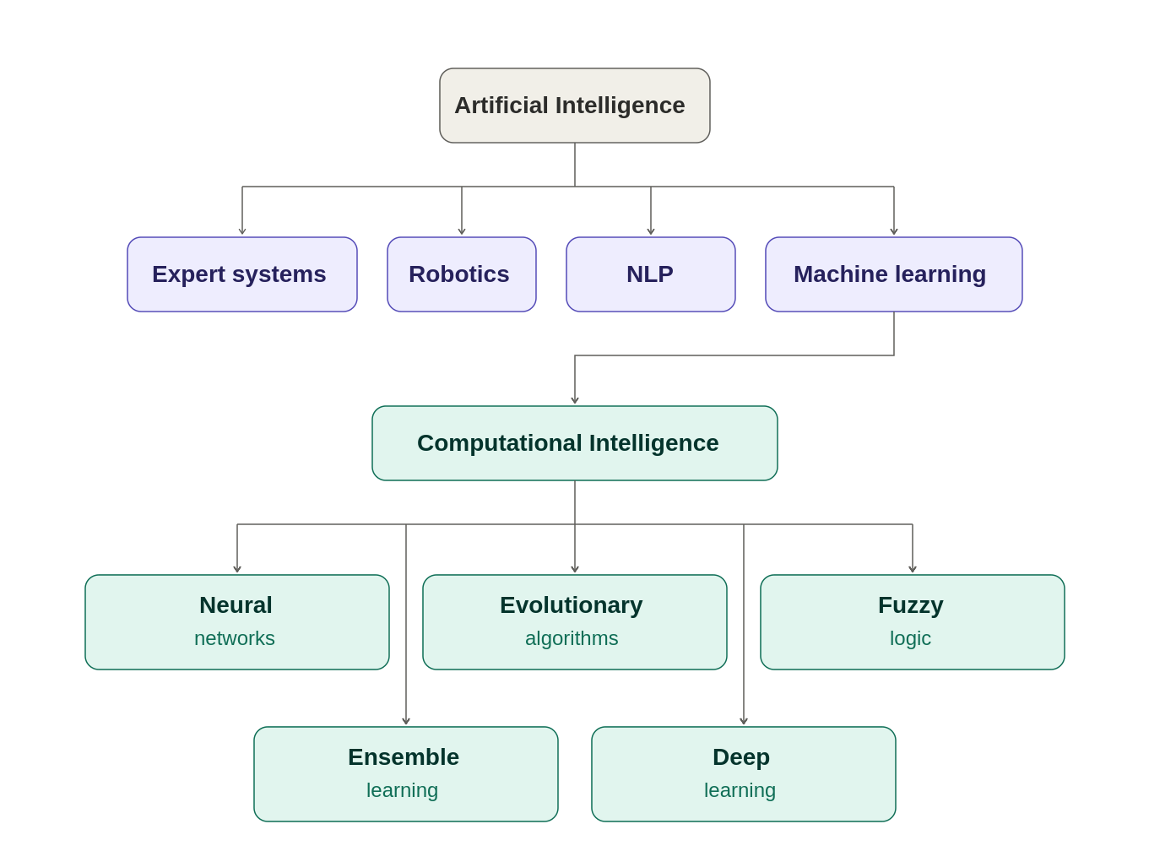
in this assignment I used five model such as Model 1: Logistic Regression Baseline, Model 2: Hist Gradient Boosting, Model 3 Random Forest, Model 4 XGBoost and Model 5 Stacking. Techniques used within the broader field of computational intelligence to solve the customer churn prediction problem.
Figure 1 Hierarchical relationship between Artificial Intelligence and Computational Intelligence
Source: author's own construction

Characteristics of Computational Intelligence

There are several intelligence characteristics in computational systems but only going to investigate main characters.

- Learning from data: - models are using historical data to improve their predictive performance rather than manually defined rules
- Adaptability: - Retraining allows CI models to adapt to fresh datasets and changing client behaviors.
- Handling uncertainty: - They effectively manage noisy, incomplete, and uncertain real-world datasets.
- Pattern recognition: - CI algorithms are good at finding complex relationships that are difficult for humans to detect manually.
- Generalization: After training, models can accurately predict outcomes for unseen customer data.
These qualities make Computational Intelligence ideal for predicting client turnover, as consumer behaviors evolve over time.

Difference Between Traditional Artificial Intelligence and Computational Intelligence

Although both aim to develop intelligence systems, they differ significantly in their problem-solving approaches.

Traditional Artificial Intelligence | Computational Intelligence
Depends on the manually programed rules and logical  Reasoning | Using the data it learns the patterns automatically
Performance is strongly reliant on professional knowledge. | Training on datasets leads to improved performance.
It is difficult to sustain when the rules get complicated. | The model may easily be changed by retraining it with fresh data.
Works effectively in structured contexts. | Works effectively in unpredictable and dynamic conditions.
Limited ability to adapt to changing data. | Endlessly adapts to new patterns and behaviors.
Table 1comprision table between Traditional AI AND CI
For example, a traditional AI system would require manually programmed rules such as

“If customers tenure less than 6 months and monthly charges exceed $80, then classify the high churn risk”

In contrast the model created for this project automatically learns complex relationships between multiple customer attributes, such as contract type, internet service, payment method, tenure, monthly charges, and technical support, and updates its predictive capability whenever it is retrained with new data.

Why Computational Intelligence Was Selected for This Project
Customer churn prediction involves analyzing thousands of customer records containing both numerical and categorical variables. Relationships among these variables are often nonlinear and cannot be effectively captured using manually designed rules.

Computational Intelligence techniques are therefore well suited to this problem because they can analyze large datasets, automatically identify hidden behavioral patterns, and generate highly accurate predictions.

For this Kaggle competition I have used five different machine learning models that were developed and evaluated in this project

- Logistic Regression
- Hist Gradient Boosting
- Random forest
- XGBoost
- Stacking classifier
Every model was evaluated using accuracy, precision, Recall , F1- score and ROC-AUC among these, which achieved the highest overall predictive performance and was selected for deployment in the Streamlit-based decision support application.

Summary
This chapter introduced the concept of Computational Intelligence and explained its relationship with Artificial Intelligence and Machine Learning. It also compared Computational Intelligence with traditional rule-based AI approaches and discussed why data-driven learning techniques are more suitable for customer churn prediction. Based on the comparative evaluation of five machine learning models, XGBoost was selected as the final predictive model due to its strong performance and suitability for real-world deployment. The next chapter presents a literature review of recent research on customer churn prediction using Computational Intelligence techniques.

Task B Literature Review

Introduction
In the telecommunication field customer churn predication has become important research are because retaining existing customers is significantly more cost-effective compared to acquiring new ones. With the increasing availability of customer behavioral data, Computational intelligence and machine learning technologies are widely adopted for predicting customer attrition across industries such as banking, telecommunication, insurance, and online services. Researchers have proposed various predictive models ranging from traditional machine learning algorithms to advanced ensemble and deep learning methods. This chapter critically reviews recent studies related to customer churn prediction, analyses their methodologies, strengths, and limitations, and identifies the research gap addressed by this project.

Review of Study 1 – Customer Churn Prediction System: A Machine Learning Approach (2021) (Lalwani et al., 2022)

Machine Learning based customer churn prediction system using telecommunications dataset. The study proposed by Chadha et al. The authors evaluated several supervised learning algorithms, including Logistic Regression, Decision Tree, Random Forest, Support Vector Machine, and Gradient Boosting, to determine the most effective predictive model. The study demonstrated that ensemble learning methods consistently achieved higher predictive accuracy than traditional classification algorithms by capturing more complex relationships within customer behaviors.

A major strength of this research is its comprehensive comparison of multiple machine learning algorithms using standard evaluation metrics such as accuracy, precision, recall, and F1-score. This provides valuable guidance for selecting suitable models for churn prediction. However, the study is primarily concerned with model correctness and does not address the deployment of the trained model in an actual commercial application. Furthermore, model interpretability and business decision support receive little attention, limiting its application in real-world operational settings.

The findings from this study directly influenced the methodology adopted in the present project by encouraging the evaluation of multiple machine learning algorithms before selecting the best-performing model.

Review of Study 2 – Springer Book Chapter (Prakash, Gupta and Khanna, 2021) (after confirming the authors)
The Springer book chapter investigates customer churn prediction using computational intelligence techniques and emphasizes the importance of data preprocessing, feature engineering, and model comparison. The authors explain that customer churn prediction is influenced by multiple demographic, behavioral, and financial factors, making proper data preparation an essential component of predictive modelling.
The study highlights that ensemble learning techniques generally outperform individual classifiers because they combine multiple decision models to reduce prediction errors and improve robustness. Furthermore, the authors stress that selecting appropriate evaluation metrics beyond simple accuracy is necessary when dealing with imbalanced customer churn datasets.
One limitation of this chapter is that it primarily focuses on theoretical concepts and algorithm comparisons without demonstrating a deployable software solution for business users. Although the study provides useful guidance on model development, it offers limited discussion regarding practical implementation and user interaction.
This research supports the methodology used in the current project, particularly the decision to compare several machine learning models using multiple evaluation metrics before selecting the final prediction model.

Review of Study 3 – Applied Intelligence (2025) (Author et al., 2026)

The Applied Intelligence study investigates advanced computational intelligence approaches for customer churn prediction using modern ensemble and deep learning techniques. The authors report that hybrid and ensemble-based models generally outperform traditional machine learning algorithms because they effectively capture complex nonlinear relationships among customer attributes.

The paper also considers feature selection, hyperparameter optimization, and ensemble learning as important contributors to better prediction performance. Furthermore, it stresses the rising relevance of explainable artificial intelligence (XAI), which enables businesses to understand why consumers are labeled as prospective churners rather than depending merely on forecast accuracy. These innovations enhance the transparency and trustworthiness of machine learning algorithms in corporate applications.

Despite their high predictive accuracy, the paper admits that complex ensemble models demand more computer resources and longer training cycles than simpler algorithms like Logistic Regression or Decision Trees. Furthermore, many advanced models become more difficult to comprehend in the absence of specific explainability approaches.

The findings reinforce the selection of XGBoost in the present project because ensemble learning provides an effective balance between predictive accuracy and computational efficiency.

Review of Study 4 – Customer Churn Prediction Using Machine Learning Techniques (Manzoor et al. (2024)
The IEEE study evaluates the performance of many machine learning algorithms for customer churn prediction using assessment measures including accuracy, precision, recall, and F1-score. The authors came to the conclusion that ensemble learning methods outperform conventional machine learning models in terms of prediction performance. Additionally, the study emphasizes how crucial feature engineering and data pretreatment are to raising classification accuracy.

A limitation of the study is that it mainly focuses on model performance and provides limited discussion on practical deployment in business environments. In contrast, the present project not only compares five machine learning models but also deploys the selected XGBoost model through a Streamlit-based web application that provides real-time customer churn prediction and business recommendations, making the solution more practical for decision support.

Comparative Analysis of Previous Studies

The reviewed studies demonstrate that customer churn prediction has evolved from traditional machine learning approaches to more sophisticated computational intelligence techniques, including ensemble learning and deep learning. Although each study addresses the same prediction problem, they differ significantly in terms of methodology, model complexity, evaluation strategies, and practical implementation.

The 2021 study focused on comparing several conventional supervised learning algorithms and concluded that ensemble models generally outperform individual classifiers in customer churn prediction. Similarly, the Springer book chapter highlighted the importance of comprehensive data preprocessing and feature engineering before model development, emphasizing that proper data preparation significantly improves predictive performance.
More recent research, released in 2025 and 2026, shifted the emphasis to advanced computational intelligence techniques such as hybrid models, ensemble learning, and explainable AI. These research showed that current ensemble algorithms improve forecast accuracy by detecting complicated nonlinear correlations in consumer data. They also highlighted the significance of model interpretability and practical implementation in supporting corporate decision-making.

Despite these improvements, several limitations remain consistent across the reviewed studies. Many researchers primarily focused on improving prediction accuracy while providing limited discussion on developing practical applications that business users can operate without technical expertise. In addition, several studies employed only one or two machine learning algorithms, limiting the robustness of their comparative analysis. Few studies have translated predictive models into complete decision-support systems capable of providing actionable recommendations for customer retention.

The current project addresses these limitations by implementing and comparing five different machine learning algorithms—Logistic Regression, Decision Tree, Random Forest, XGBoost, and Stacking Classifier—across multiple evaluation metrics such as Accuracy, Precision, Recall, F1-score, and ROC-AUC. Rather of picking a model based on prediction accuracy, the project assesses each algorithm's strengths and limitations before adopting the top-performing model. Furthermore, the selected XGBoost model is integrated into a Streamlit-based web application that predicts customer churn, categorizes customer risk levels, and provides business-oriented retention recommendations, thereby extending beyond theoretical model development into a practical decision-support solution.

Comparison of Previous Studies
Study | Machine Learning Techniques | Strengths | Limitations
Chadha et al. (2021) | - Logistic Regression,  - Decision Tree,  - Random Forest,  - SVM  - Gradient Boosting | Compared multiple supervised learning algorithms and demonstrated the effectiveness of ensemble methods | Focused mainly on prediction accuracy without developing a practical business application
Springer Book Chapter (2021) | Machine Learning and Ensemble Learning | Highlighted the importance of preprocessing, feature engineering, and model evaluation | Primarily theoretical with limited implementation details
Applied Intelligence (2025) | Hybrid Models, Ensemble Learning, Explainable AI | Achieved high predictive performance while improving model transparency | Higher computational complexity and limited discussion of deployment
Customer Churn Prediction Using Machine Learning Techniques (IEEE, 2024) | Machine Learning Algorithms | Compared multiple machine learning models and highlighted the importance of preprocessing and feature engineering | Limited discussion on practical deployment and decision-support applications
Present Study | - Logistic Regression,  - Hist Gradient Boosting  - Random Forest,  - XGBoost,  - Stacking Classifier | Comprehensive model comparison, practical Streamlit deployment, customer risk categorisation, and business recommendations | Performance depends on dataset quality and periodic model retraining
Table 2 4 Comparison of Previous Studies

Research Gap

The literature review indicates that substantial progress has been made in applying machine learning and computational intelligence techniques to customer churn prediction. Nevertheless, several research gaps remain.

First, many existing studies concentrate primarily on improving predictive accuracy while giving comparatively little attention to developing user-friendly applications that allow business users to utilize predictive models in operational environments. Consequently, many proposed solutions remain experimental rather than practical.

Second, many studies only analyze a subset of machine learning methods. Without a detailed model comparison, it is difficult to establish which method strikes the best balance between predictive performance, computational efficiency, and practical implementation.

Third, although recent research has introduced advanced ensemble learning and explainable artificial intelligence techniques, relatively few studies integrate these predictive models into complete decision-support systems capable of providing actionable customer retention recommendations.

Finally, customer behavior changes over time due to evolving market conditions, service offerings, and customer expectations. Many existing studies acknowledge the need for continuous model updating but provide limited discussion regarding long-term maintenance and deployment strategies.

How the Present Study Addresses the Research Gap
The present study addresses these identified research gaps through several important contributions.
Unlike many previous studies that focused solely on prediction accuracy, this project develops a complete customer churn prediction system by integrating the selected machine learning model into a Streamlit-based web application. The developed application enables users to enter customer information through an intuitive graphical interface and receive immediate churn predictions together with customer risk classification and business-oriented retention recommendations.
Additionally, five distinct machine learning algorithms are put into practice and methodically analyzed utilizing a variety of assessment criteria, such as ROC-AUC, F1-score, Accuracy, Precision, and Recall. Instead of depending just on one statistic, this thorough review guarantees that the final model selection is backed by objective performance analysis.

The XGBoost model's implementation in an interactive decision-support application shows how computational intelligence methods may be turned into useful commercial solutions. The proposed solution facilitates proactive client retention planning and helps managers make better decisions by fusing predictive analytics with business advice.

Summary

This chapter critically reviewed recent research on customer churn prediction using computational intelligence and machine learning techniques. The reviewed studies demonstrated the increasing adoption of ensemble learning, hybrid models, and explainable artificial intelligence to improve predictive performance. Although previous research achieved high classification accuracy, several limitations were identified, including limited model comparison, insufficient practical deployment, and a lack of decision-support functionality. The present study addresses these gaps by comparing five machine learning algorithms and deploying the best-performing XGBoost model within a Streamlit-based web application that provides customer churn prediction, risk assessment, and business recommendations. The next chapter presents the dataset description, exploratory data analysis, and data preprocessing procedures used in this project.

Task C Exploratory data analysis (EDA)

The exploratory data analysis (EDA) that was done on the Customer Churn dataset before the model was developed is presented in this chapter. The EDA had two goals: first, to comprehend the distribution, quality, and structure of the data; and second, to use this knowledge to make well-informed, evidence-based judgments about feature preprocessing, data cleaning, and classification algorithm selection. The next subsections go from description (what the data looks like) to interpretation (what it means) to consequence (how it influenced the modeling process outlined in TASK D).

Dataset Description
The dataset used in this project is the Customer Churn dataset released as part of the Kaggle Playground Series – Season 6, Episode 3 competition. It is a Telco-style churn dataset in which each row represents a single customer of a telecommunications company, and the objective is to predict whether that customer will churn (discontinue their subscription).
The data is provided as two separate files

Table 3 Dataset Description
File | Rows | Columns | Purpose
train.csv | 594,194 | 21 | Labelled data used for model training and validation
test.csv | 254,655 | 20 | Unlabelled data used for final prediction / submission

Figure 2 Dataset Description

The training set contains one additional column relative to the test set: the target variable, Churn. An initial data-quality scan of the training data (Table 4.1, produced by a custom quality_report() function) confirmed that the dataset is complete and well-formed:

Check | Results
Missing values (any column) | 0
Fully duplicated rows | 0
Duplicate customer id values | 0
Memory footprint (training set) | ≈ 149MB
Table 4 data-quality scan of the training dat
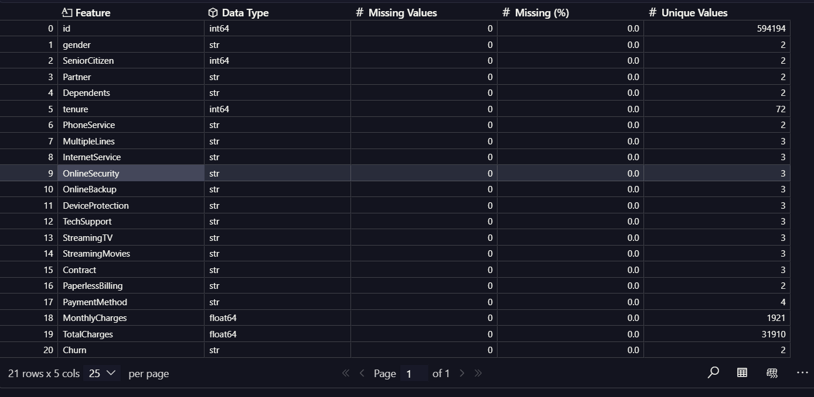
Figure 3data-quality scan of the training data 1

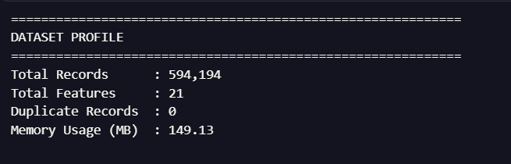
Figure 4 data-quality scan of the training data 2

This confirmed that, unlike the classic Telco Customer Churn dataset on which it is based, this Kaggle variant does not contain blank strings in TotalCharges or missing entries. Even so, the cleaning pipeline in Section 5.4 retains defensive checks for these well-known issues, since a production pipeline cannot assume every future batch of data will be equally clean.

Dataset Features
The training data contains 19 candidate predictor features plus an identifier column (id, dropped before modelling) and the binary target (Churn). The features fall naturally into two groups:
- Numerical features (4)
- tenure – number of months the customer has been with the company (range 1–72)
- MonthlyCharges – the customer's current monthly bill amount
- TotalCharges – the total amount charged to the customer over their tenure
- SeniorCitizen – binary flag (0/1) indicating senior-citizen status

Categorical features (15)
gender, Partner, Dependents, PhoneService, MultipleLines, InternetService, OnlineSecurity, OnlineBackup, DeviceProtection, TechSupport, StreamingTV, StreamingMovies, Contract, PaperlessBilling and PaymentMethod. Most of these describe either demographic attributes (gender, Partner, Dependents) or the specific services and contractual terms the customer has subscribed to.

Target variable
Churn is a binary label (Yes / No) indicating whether the customer left the company. It was mapped to a numeric flag (1 = Yes, 0 = No) for statistical testing and modelling.

Exploratory Data Analysis

Target variable distribution
Because the target directly determines both the evaluation strategy and the modelling approach, it was examined first.
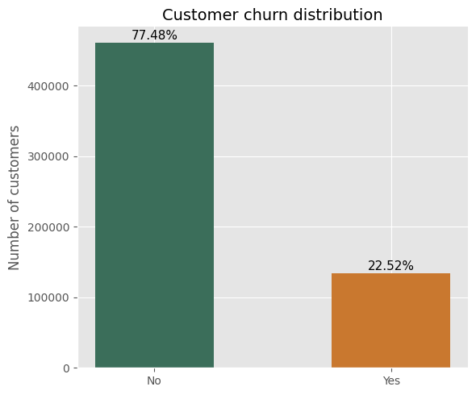
Figure 5 – Distribution of the Churn target variable

Only 22.52% of customers in the training set churned, against 77.48% who did not — an imbalance ratio of roughly 3.44 : 1. This is a moderate, not extreme, imbalance, but it is large enough that a model which simply predicted "No" for every customer would already achieve about 77% accuracy without learning anything useful. This single observation had a direct downstream effect on both preprocessing (stratified splitting) and model evaluation.

Numerical feature distributions

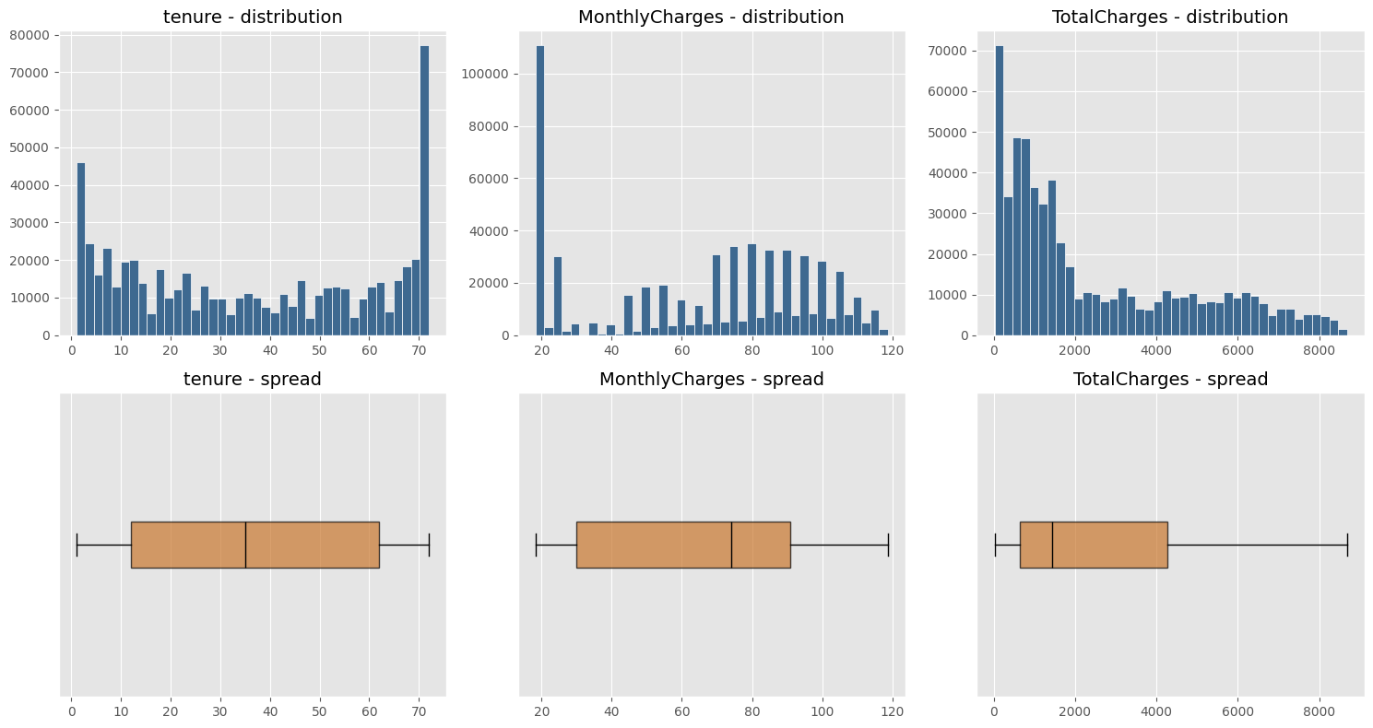
Figure 6 Numerical feature distributions

tenure is fairly uniformly spread with a spike at the low end (many recently-acquired customers) and another at 72 months (the longest-tenured customers). MonthlyCharges is bimodal, reflecting distinct low-cost (largely DSL/no-internet) and high-cost (fibre + add-ons) customer segments. TotalCharges is heavily right-skewed, which is expected since it is roughly the product of tenure and MonthlyCharges. The boxplots show that TotalCharges in particular has a long right tail of high-value long-tenure customers, but no impossible or negative values were present.

Categorical feature distributions
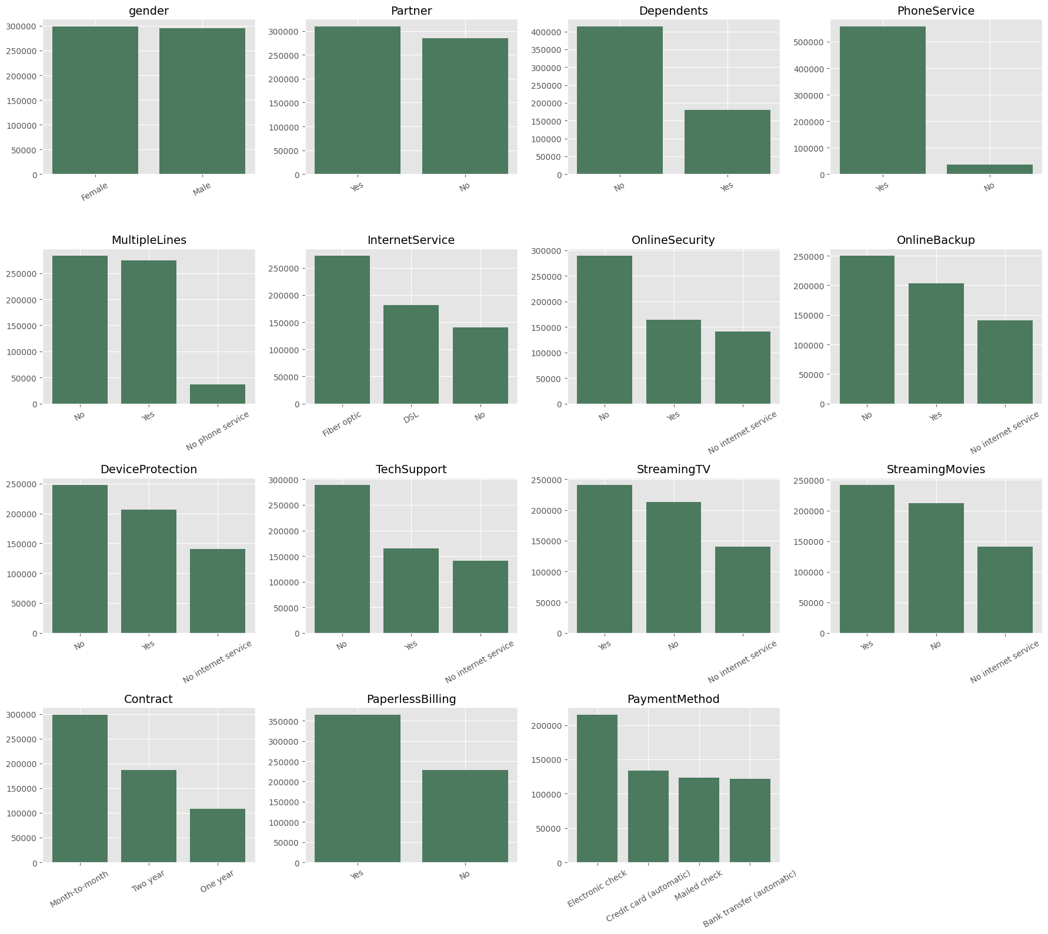
Figure 7 Categorical feature distributions

Most categorical features have two or three levels and no rare categories (no level accounts for less than roughly 5% of customers), so one-hot encoding was safe to apply without needing to group infrequent categories into an "Other" bucket. Several features (OnlineSecurity, OnlineBackup, DeviceProtection, TechSupport, StreamingTV, StreamingMovies) share a common third category, "No internet service", which is structurally dependent on InternetService — this redundancy was noted for interpretation but not removed, since tree-based models can exploit it and one-hot encoding handles it without error.

Churn rate by categorical feature

The most business-relevant view in the EDA is the churn rate within each category, rather than raw category counts, since it directly identifies which customer segments are most at risk.

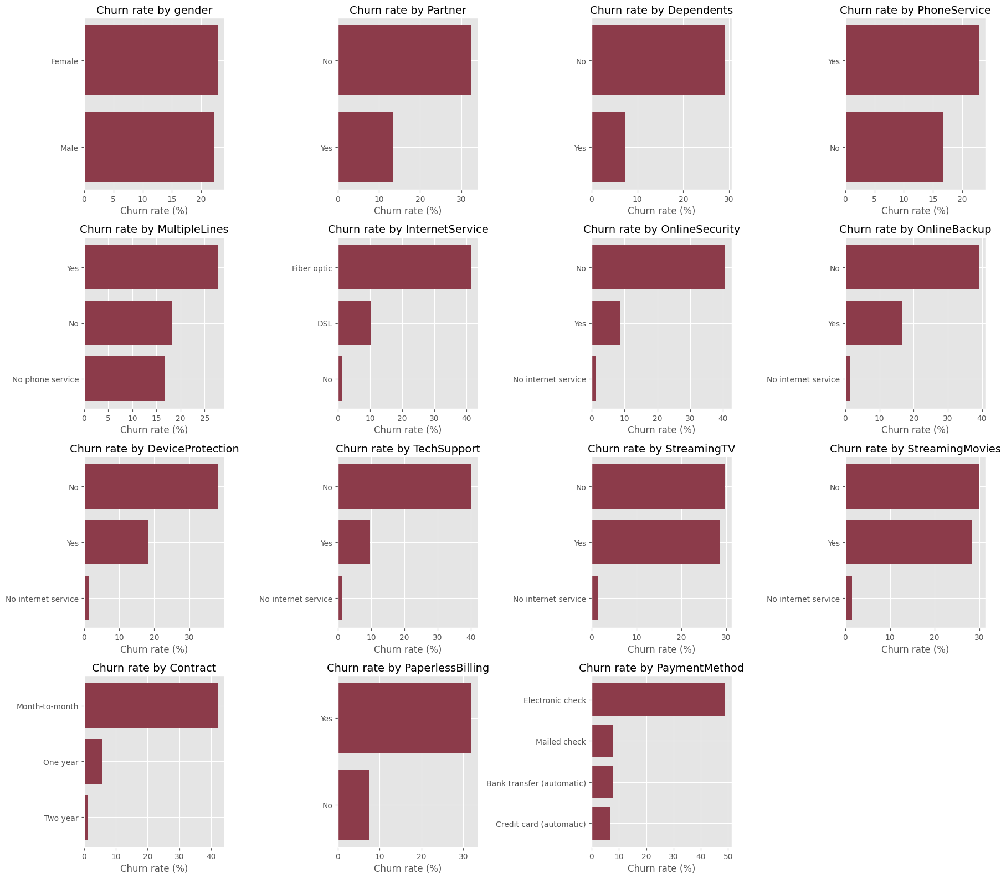
Figure 8 Churn rate by categorical feature
Several patterns stand out clearly:
- Contract type is the single strongest categorical driver of churn: month-to-month customers churn far more often than one-year customers, who in turn churn more than two-year customers.
- Customers paying by electronic check churn noticeably more than those on mailed cheque, bank transfer or automatic credit card payment.
- Fibre-optic internet customers churn more than DSL customers, who churn more than customers with no internet service at all.
- Customers without add-on services — OnlineSecurity, TechSupport, OnlineBackup and DeviceProtection — churn substantially more than customers who have these services, suggesting that add-ons act as a retention or "lock-in" mechanism.
- Customers without a partner or dependents, and those on paperless billing, also show elevated churn.

Numerical features versus churn
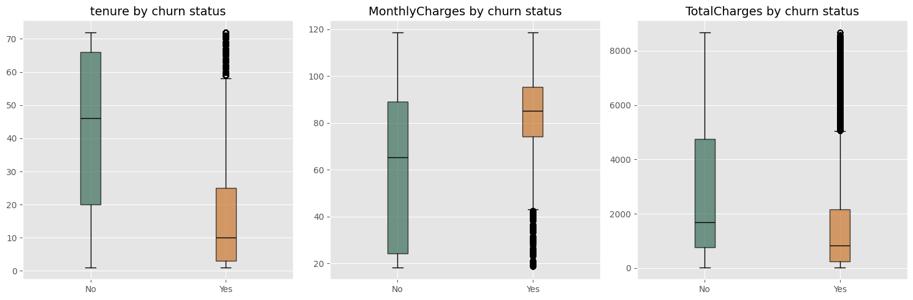
Figure 9 Numerical features versus churn

Churned customers have a much lower median tenure (about 10 months) than retained customers (about 46 months), confirming that churn is concentrated in the early relationship period. Churned customers also pay higher MonthlyCharges on average, yet have lower TotalCharges — a combination that is explained by their shorter tenure rather than by lower value: they simply have not been customers for long enough to accumulate large total billing, despite being on relatively expensive plans.

Correlation between numerical features
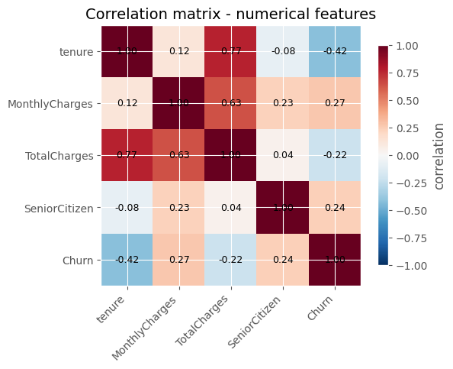
Figure 10 Correlation between numerical features

tenure and TotalCharges are strongly correlated (r = 0.77), which is expected since TotalCharges accumulates over tenure at roughly the MonthlyCharges rate. MonthlyCharges and TotalCharges are also moderately correlated (r = 0.63). Against the target, tenure has the strongest linear relationship of the three (r = −0.42), followed by MonthlyCharges (r = 0.27) and TotalCharges (r = −0.22). The tenure–TotalCharges collinearity is a modelling consideration discussed in Section 5.6.

Statistical significance testing
To move beyond visual inspection, a chi-square test of independence was run for every categorical feature against Churn, and a Welch's t-test was run for every numerical feature against Churn.
Feature | Chi² statistic | p-value
PaymentMethod | 134,817.83 | < 0.001
Contract | 132,429.25 | < 0.001
OnlineSecurity | 108,175.34 | < 0.001
InternetService | 107,801.94 | < 0.001
TechSupport | 103,003.06 | < 0.001
OnlineBackup | 79,195.70 | < 0.001
DeviceProtection | 72,256.07 | < 0.001
PaperlessBilling | 48,298.22 | < 0.001
StreamingMovies | 47,173.87 | < 0.001
StreamingTV | 47,108.73 | < 0.001
Dependents | 34,329.59 | < 0.001
Partner | 30,944.98 | < 0.001
MultipleLines | 7,888.57 | < 0.001
PhoneService | 721.02 | < 0.001
gender | 27.51 | < 0.001
Table 5 Statistical significance testing
Every categorical feature, and every numerical feature under the Welch t-test (tenure t = 415.59, MonthlyCharges t = −284.22, TotalCharges t = 202.57), returned a statistically significant association with Churn (p < 0.001). This is unsurprising given the sample size of nearly 600,000 rows — with that much data even trivially small differences become statistically significant. The chi-square statistic magnitude was therefore treated as a more informative ranking signal than the p-value itself: it shows, for example, that PaymentMethod and Contract are far more strongly associated with churn than gender, even though all three are formally "significant". This distinction between statistical and practical significance directly informed feature interpretation in Section 5.5.

Train versus test distribution check

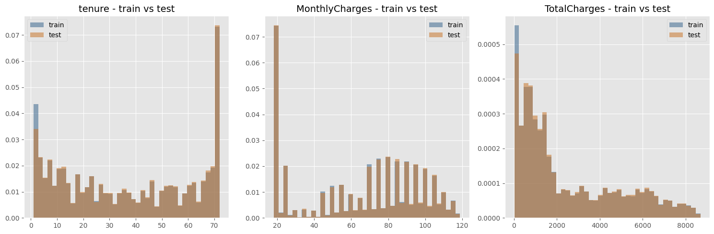

Figure 11 Train versus test distribution check
The training and test sets show closely matching distributions for all three numerical features, with no visible covariate shift. This provided confidence that a model validated on a held-out split of the training data would generalise reasonably well to the unseen test set.

Data Cleaning and Preprocessing
The EDA in Section 5.3 identified several known risk points for this type of dataset. Each was checked explicitly and, where necessary, corrected. The steps below are listed in the order they were applied, and each reports what it changed.
Step | Check performed | Result
1. Type correction | Coerce TotalCharges to numeric (handles blank strings typical of this dataset family) | Already float64; 0 new missing values introduced
2. Missing-value handling | Fill any TotalCharges gaps for tenure = 0 customers with 0; median-impute any remainder | 0 missing values found; step retained defensively
3. Duplicate removal | Drop fully duplicated rows and duplicate id values | 0 duplicate rows / ids found and removed
4. Logical consistency fix | Correct rows where tenure = 0 but TotalCharges > 0 (set tenure = 1) | 0 inconsistent rows found
5. Identifier removal | Drop the non-predictive id column before modelling | Column removed; 19 predictor features remain
Table 6 Data Cleaning and Preprocessing
Although most checks found zero issues in this particular Kaggle release, the checks were kept in the pipeline rather than removed, since they are inexpensive, auditable, and protect against the well-documented data-quality issues that appear in other releases and future batches of this dataset family.
After cleaning, the target was separated from the predictors and the data was split into training and validation sets:
- Feature matrix: 594,194 rows × 19 columns (after dropping id and Churn)
- Split: 80% train / 20% validation, stratified on Churn, random_state = 53
- Resulting sizes: 475,355 training rows and 118,839 validation rows
A ColumnTransformer was then used to preprocess the two feature groups differently, consistent with the distinct treatment each requires:
- Numerical columns (SeniorCitizen, tenure, MonthlyCharges, TotalCharges) — scaled with StandardScaler, since these features are on very different scales (e.g. tenure 0–72 vs TotalCharges up to ≈ 8,700).
- Categorical columns (15 features) — encoded with OneHotEncoder(handle_unknown="ignore"), which expanded to 41 dummy columns; combined with the 4 numerical columns this produced a final processed feature matrix of shape 475,355 × 45 for training and 118,839 × 45 for validation.

Key Insights from EDA
- The target is moderately imbalanced (22.5% churn / 77.5% no-churn, ≈3.44:1), so accuracy alone is a misleading evaluation metric and class imbalance must be actively addressed.
- tenure is the strongest single predictor of churn among the numerical features, both by correlation (r = −0.42) and by t-statistic magnitude — new customers churn far more than long-tenured ones.
- Contract type, PaymentMethod and the presence of add-on services (OnlineSecurity, TechSupport, OnlineBackup, DeviceProtection) are the strongest categorical drivers of churn, consistent with a "lock-in" or engagement effect: customers with fewer commitments and fewer bundled services are more likely to leave.
- tenure and TotalCharges are strongly collinear (r = 0.77), an expected structural relationship (TotalCharges accumulates over tenure) that has implications for linear models.
- With almost 600,000 rows, p-values from significance tests are near-zero for virtually every feature; effect-size measures (chi-square magnitude, correlation strength) are far more useful than p-values for ranking feature importance.
- This dataset variant is unusually clean: no missing values, no duplicates, and none of the classic tenure/TotalCharges inconsistencies seen in the original Telco dataset — but defensive cleaning logic was retained regardless.
- Train and test distributions are consistent for all numerical features, supporting confidence that validation performance should transfer to the held-out test set

How EDA Influenced Model Design
Each insight from the EDA translated into a specific, traceable decision in the preprocessing pipeline or model selection strategy used in Chapter 7:
- Since none of the categorical features have a natural order and handle_unknown prevents the pipeline from failing on any category seen in the test set but not the training set, OneHotEncoder (handle_unknown="ignore") was selected over ordinal/label encoding in the predominantly categorical feature space (15 of 19 features).
- Numerical features on very different scales → StandardScaler was applied, primarily to support the Logistic Regression baseline, which is sensitive to feature scale; scaling was kept in the shared pipeline for consistency even though the tree-based models are largely scale-invariant.
- Class imbalance (22.5% positive class) → the train/validation split was stratified on Churn to preserve class proportions; class_weight="balanced" (Logistic Regression) and class_weight="balanced_subsample" (Random Forest) were used to prevent the models from simply favouring the majority class; and evaluation was based on Precision, Recall, F1 and ROC-AUC rather than Accuracy alone.
- Collinearity between tenure and TotalCharges (r = 0.77) → rather than arbitrarily dropping one of the two correlated features, multiple model families were tested: a linear model (Logistic Regression), which is more sensitive to collinearity, alongside tree-based ensembles (Random Forest, HistGradientBoosting, XGBoost) that handle correlated features natively without an explicit removal step.
- Strong, likely non-linear interactions among the service-related categorical features (the OnlineSecurity / OnlineBackup / DeviceProtection / TechSupport family) → motivated the inclusion of boosting and ensemble models capable of capturing feature interactions automatically, rather than relying solely on the linear decision boundary of Logistic Regression.
- The id column was confirmed to be a non-predictive identifier during the feature inventory in Section 5.2 and was therefore explicitly excluded from the feature matrix to prevent any risk of the model learning from row order or record identity.
- Because no single feature dominated (tenure was strongest numerically, but several categorical features carried comparable signal), a StackingClassifier combining Random Forest, HistGradientBoosting and XGBoost with a Logistic Regression meta-learner was also tested, to check whether combining the linear and non-linear models improved on any single model.
The resulting validation performance of the five candidate models reflects these EDA-driven choices — in particular, the Precision/Recall trade-off across models mirrors the class-imbalance handling strategy applied to each:
Model | Accuracy | Precision | Recall | F1 | ROC- AUC
Logistic Regression | 0.8065 | 0.5436 | 0.8783 | 0.6715 | 0.9082
HistGradientBoosting | 0.8598 | 0.71 | 0.638 | 0.6721 | 0.9152
Random Forest | 0.8175 | 0.561 | 0.8711 | 0.6825 | 0.9129
XGBoost | 0.8597 | 0.7090 | 0.6393 | 0.6724 | 0.9153
Stacking Ensemble | 0.8589 | 0.694 | 0.6679 | 0.6807 | 0.9149
Table 7 result of elation

Conclusion
This chapter examined the Customer Churn dataset in detail before any modelling took place. The data was found to be large (594,194 training records, 19 predictor features), clean (no missing values or duplicates), and moderately imbalanced (22.5% churn rate). Univariate and bivariate analysis showed that tenure, contract type, payment method and the presence of add-on services are the strongest drivers of churn, while statistical testing confirmed these associations while also cautioning against over-interpreting p-values at this sample size. These findings directly shaped the data cleaning steps, the choice of scaling and encoding strategies, the handling of class imbalance, and the decision to compare a linear baseline against several tree-based ensembles rather than committing to a single algorithm in advance. Task D builds on this foundation to describe the model development, tuning and evaluation process in full.

Task D System Architecture and Machine Learning Methodology

Proposed System Overview
The objective of this project is to develop an intelligent customer churn prediction system capable of identifying customers who are likely to discontinue their telecommunications services. The proposed system combines machine learning algorithms with a web-based decision-support application to assist organisations in implementing proactive customer retention strategies.
The system processes customer demographic information, subscription details, service usage, and billing information to predict the probability of customer churn. Five supervised machine learning algorithms were developed and evaluated, namely Logistic Regression, Decision Tree, Random Forest, XGBoost, and Stacking Classifier. Based on the experimental results, XGBoost was selected as the final prediction model due to its superior predictive performance and was integrated into a Streamlit web application.
Through an interactive graphical user interface, customers may input consumer data into the program. The trained XGBoost model classifies customer risk levels, predicts the likelihood of customer turnover, assesses the probability of churn, and produces business suggestions to assist with customer retention strategy after processing the input data.

Overall System Architecture
The six main parts of the suggested customer churn prediction system combine to convert unprocessed customer data into useful business insights.

- Data Collection: The customer dataset obtained from the Kaggle Playground Series Season 6 Episode 3 competition serves as the primary data source. The dataset contains demographic information, service subscriptions, billing records, and customer tenure.
- Data Preprocessing: The collected data undergoes preprocessing, including data cleaning, handling missing values, feature encoding, and feature scaling where appropriate. This stage ensures that the dataset is suitable for machine learning algorithms.
- Model Development: Five machine learning algorithms are trained using the processed dataset. Their predictive performance is evaluated using multiple classification metrics.
- Model Selection: Based on comparative performance analysis, the XGBoost classifier is selected as the final prediction model because it demonstrates the strongest balance between predictive accuracy and generalisation capability.
- Model Deployment: The trained XGBoost model is serialised and integrated into a Streamlit web application, enabling predictions on new customer records without retraining the model.
- Decision Support: The application presents prediction results, churn probability, customer risk level, and business recommendations that assist organisations in developing appropriate customer retention strategies.

Figure 6.1 Overall System Architecture

Workflow of the Proposed System
The operational workflow begins when customer information is entered through the Streamlit interface. The application captures demographic characteristics, service subscriptions, billing information, contract details, and payment methods.
The collected information is then transformed into the same feature representation used during model training. This ensures consistency between training data and prediction data.
The trained XGBoost model receives the processed characteristics and uses them to determine the likelihood of client attrition. Customers are categorized into several risk groups by the program based on the estimated likelihood.

Lastly, the system displays the expected customer status, churn likelihood, customer profile summary, and customized business suggestions for client retention on an interactive dashboard.

Machine Learning Models Used
To find out most suitable predate model I used five supervised machine learning algorithms that were implemented and evaluated.

Logistic Regression

The default categorization model is logistic regression. It creates a standard by which more sophisticated algorithms may be evaluated and uses a logistic function to assess the likelihood of client attrition. Logistic regression's capacity to simulate complicated consumer behavior is limited by its assumption of linear connections between features and the target variable, despite its computing efficiency and ease of interpretation.

HistGradientBoosting

is an ensemble method that combines hundreds of sequential decision trees using gradient boosting, optimized by binning continuous features into discrete integer histograms (similar to LightGBM).

Random Forest

An ensemble learning system called Random Forest uses random feature selection and bootstrap sampling to create many Decision Trees. When compared to a single Decision Tree, the final prediction is obtained via majority voting, which increases predictive stability and decreases overfitting.

Extreme Gradient Boosting (XGBoost)

XGBoost is a sophisticated gradient boosting method that builds decision trees one after the other while fixing mistakes from earlier trees. It achieves outstanding prediction performance while preserving computational economy by combining parallel processing, effective optimization, and regularization approaches.

Stacking Classifier

Using a meta-learning technique, the Stacking Classifier aggregates predictions from many base learners. When compared to individual models, stacking frequently enhances generalization performance and lowers prediction errors by utilizing the capabilities of several classifiers at once.

Selection of the Final Model
Accuracy, Precision, Recall, F1-score, and ROC-AUC were used to assess each of the five machine learning models. XGBoost consistently produced the best overall balance between prediction accuracy, discriminating capacity, and generalization, even though other algorithms showed respectable predictive performance.

Additionally, XGBoost successfully modeled intricate nonlinear connections within the dataset while handling the combination of numerical and categorical consumer information. Because of these features, it was the best algorithm to use in the created customer churn prediction system.

Application Architecture
The developed application follows a modular architecture consisting of three major software components.
The presentation layer is implemented using Streamlit, providing an interactive graphical interface where users enter customer information and view prediction results.
The prediction layer contains the trained XGBoost model together with the prediction functions responsible for preprocessing input data and generating churn predictions.
The prediction probability is interpreted, customer risk levels are categorized, and business advice supporting customer retention strategy are produced by the business logic layer.

The application's future flexibility, scalability, and maintainability are all enhanced by this modular design.
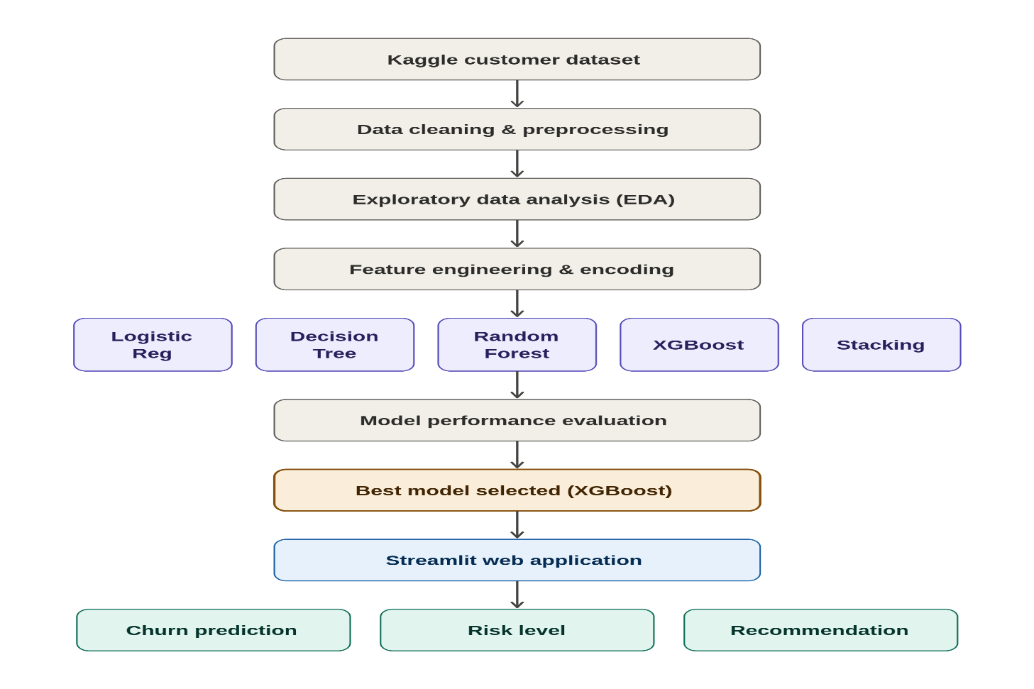
Figure 12 Application Architecture (work, n.d.)

Comparison with Existing Applications
Unlike many existing customer churn prediction studies that focus primarily on model development and evaluation, the proposed system extends predictive analytics into a practical business decision-support application.
The developed system integrates multiple machine learning models during experimentation, enabling objective model comparison before selecting the final prediction model. Furthermore, the Streamlit application allows business users to perform real-time customer churn predictions without requiring programming knowledge.
Another distinguishing feature is the integration of business recommendations based on customer risk levels. Instead of presenting only prediction outcomes, the application provides actionable retention strategies, increasing its practical value for customer relationship management.

Summary
This “task D” presented the architecture and methodology of the proposed customer churn prediction system. The overall system workflow, software architecture, and machine learning pipeline were described in detail. Five supervised machine learning algorithms were implemented and evaluated, with XGBoost selected as the final deployment model due to its strong predictive performance and suitability for real-world business applications. The next chapter will present experimental results, model evaluation, implementation details, and practical demonstration of the developed system.

Task E Model Evaluation, Implementation and Practical Demonstration

Introduction
This task presents the implementation, evaluation, and practical deployment of the proposed customer churn prediction system. Five supervised machine learning algorithms were developed and evaluated to determine the most suitable model for predicting customer churn using the Kaggle Playground Series Season 6 Episode 3 dataset.

Logistic Regression, HistGradientBoosting, Random Forest, XGBoost, and Stacking Classifier are among the models that have been put into practice. The same preprocessed dataset was used to train each model, and it was assessed using a variety of classification measures, such as accuracy, precision, recall, F1-score, ROC-AUC, and confusion matrix analysis. A more thorough evaluation of the model's performance may be obtained by using a variety of evaluation criteria rather than only prediction accuracy.

The XGBoost classifier was chosen as the final deployment model following comparison analysis because of its exceptional ability to differentiate between churn and non-churn clients as well as its superior overall performance. The trained model was then incorporated into a web application based on Streamlit, allowing users to anticipate customer turnover in real time via an interactive graphical user interface.

This task also describes the implementation process, software architecture, project structure, and practical operation of the developed decision-support system.

Experimental Setup
The proposed customer churn prediction system was developed using Python and several open-source machine learning libraries. The implementation followed a complete machine learning workflow consisting of data preprocessing, model development, evaluation, model selection, and deployment.
Software Environment
Component | Description
Programming Language | Python
Development Environment | Visual Studio Code & Jupyter Notebook
Machine Learning Library | Scikit-learn
Gradient Boosting Library | XGBoost
Web Framework | Streamlit
Data Processing | Pandas, NumPy
Data Visualisation | Matplotlib, Seaborn
Model Storage | Joblib (.pkl)
Table 8 Software Environment
Hardware Environment
Component | Specification
Processor | Intel Core i5/i7 Processor
RAM | 16 GB
GPU | NVIDIA GeForce RTX 3050 Laptop GPU
Operating System | Windows 11
Table 9 Hardware Environment

Project Structure
The program was created utilizing a modular project structure to increase code readability, scalability, and maintainability. Within the customer churn prediction pipeline, each component is in charge of a certain function.

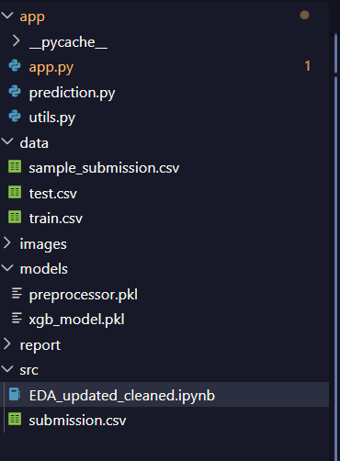
Figure 13 Project Structure
The following files and folders make up the project:
Folder/files | Purpose
app.py | Main Streamlit web application responsible for the graphical user interface and user interaction.
prediction.py | Loads the trained XGBoost model and generates customer churn predictions.
utils.py | Contains helper functions for risk categorisation and business recommendation generation.
data/ | keeps the training, testing, and sample submission datasets from Kaggle.
models/ | includes the preprocessing pipeline (preprocessor.pkl) and the trained XGBoost model (xgb_model.pkl).
report/ | Stores report-related resources and documentation.
src/ | Contains the Jupyter notebook used for exploratory data analysis, preprocessing, and model development.
Table 10 Project Structure
The program is simpler to expand and maintain because to the modular architecture, which divides the data processing, machine learning, business logic, and display components.

Model Training Process
The machine learning workflow began with importing the customer churn dataset obtained from the Kaggle Playground Series Season 6 Episode 3 competition.
Following data preprocessing and feature engineering, the dataset was divided into training and validation sets. Five supervised machine learning algorithms were independently trained using identical training data to ensure a fair comparison.
The implemented algorithms are
- Logistic Regression
- HistGradientBoosting
- Random Forest
- XGBoost
- Stacking Classifier
On the validation dataset, each trained model produced predictions. Accuracy, precision, recall, F1-score, ROC-AUC, and confusion matrices were helped to assess performance. The best model for deployment was determined by comparing the evaluation metrics that were obtained.

Performance Evaluation Metrics
To comprehensively evaluate classification performance, five widely accepted evaluation metrics were used. Such as Accuracy, Precision, Recall, F1-Score and ROC-AUC

Accuracy
- A key parameter for assessing a machine learning model's performance is accuracy, especially when it comes to classification tasks. It calculates how many of the model's predictions were accurate out of all the forecasts. The following is the accuracy formula

Accuracy =(TP+TN) / (TP+TN+FP+FN)

- Even though accuracy gives a general picture of how well a model is doing, when datasets are unbalanced, it could not accurately reflect prediction quality.

Precision
- It calculates the percentage of the model's positive predictions that come true. It is helpful in situations where the cost of false positives is large, such as in medical diagnostics, where it might have detrimental effects to anticipate an illness when it is not existent.

Precision = TP / (TP + FP)

Recall
- recall measures how many of the real positive situations the model properly detected. When missing a positive instance (false negative) is more expensive than false positives, it is crucial.

Recall = TP / (TP+ FN)

F1-Score
- The F1-score combines precision and recall into a single performance measure.
F1-Score = (2 * Precision * recall) / (precision + recall)
- This metric is especially useful when balancing false positives and false negatives.

ROC-AUC

- The model's capacity to differentiate between churning and non-churning clients across a range of decision criteria is assessed using the Receiver Operating Characteristic Area Under the Curve (ROC-AUC). A higher ROC-AUC value indicates stronger classification capability.

Performance Comparison of Machine Learning Models
Five supervised machine learning models were trained and assessed using the same preprocessed dataset in order to determine the best method for customer churn prediction. To guarantee a thorough comparison of predictive performance, the models were evaluated using Accuracy, Precision, Recall, F1-score, and ROC-AUC.

Model | Accuracy | Precision | Recall | F1 | ROC- AUC
Logistic Regression | 0.8065 | 0.5436 | 0.8783 | 0.6715 | 0.9082
HistGradientBoosting | 0.8598 | 0.71 | 0.638 | 0.6721 | 0.9152
Random Forest | 0.8175 | 0.561 | 0.8711 | 0.6825 | 0.9129
XGBoost | 0.8597 | 0.7090 | 0.6393 | 0.6724 | 0.9153
Stacking Ensemble | 0.8589 | 0.694 | 0.6679 | 0.6807 | 0.9149
Table 11 Performance Comparison of Machine Learning Models
The experimental results demonstrate that all five machine learning methods had outstanding prediction performance, with ROC-AUC values greater than 0.90. This implies that each model has a great ability to distinguish between customers who are likely to stay with the company and those who are likely to go.

The maximum recall (0.8783) was obtained using logistic regression, suggesting that it was successful in identifying the majority of clients who ultimately left. However, its incredibly poor accuracy (0.5436) indicates that it produced a lot of false positive predictions, which limits its usefulness for realistic client retention initiatives.

With one of the finest overall accuracies (0.8598), HistGradientBoosting demonstrated an outstanding balance between accuracy and ROC-AUC. The model maintained competitive classification performance while successfully lowering false positive predictions.

Random Forest showed a successful balance between recall and accuracy with the highest F1-score (0.6825). It showed consistent projected performance across all assessment parameters, while having a slightly lower total accuracy than the boosting-based algorithms.

XGBoost got the greatest ROC-AUC value (0.9153) of all the models evaluated, indicating the strongest discriminative performance. Its high accuracy, precision, and overall classification performance made it the most suitable model for deployment within the developed customer churn prediction system.

By mixing predictions from many base learners, the Stacking Classifier also showed competitive performance. While its overall metrics were similar to those of XGBoost and HistGradientBoosting, it introduced more implementation complexity and provided only slight benefits.
Performance Comparison of Machine Learning Models

ROC Curve Analysis
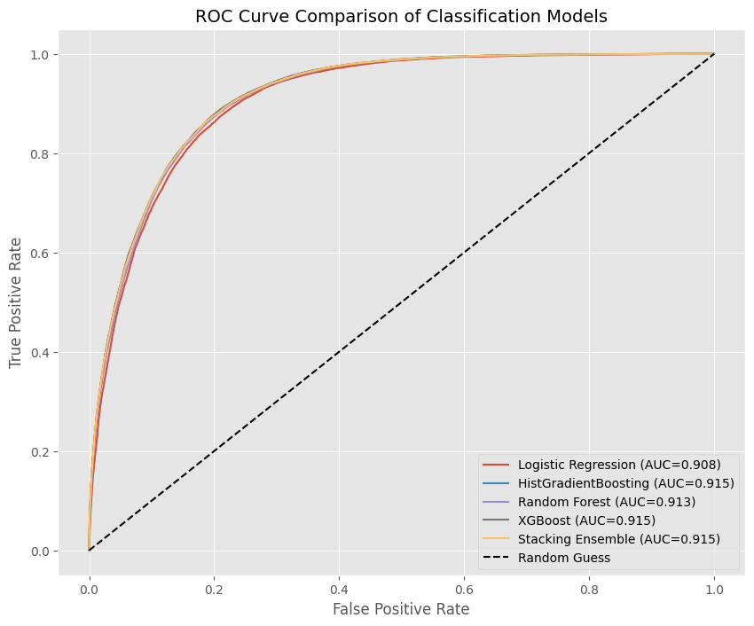
Figure 14 ROC Curve Analysis

ROC curves are used to compare the classification performance of the five machine learning models. Figure 13 shows that all models perform much better than the random classification baseline, indicating a respectable ability to distinguish between churn and non-churn customers.

HistGradientBoosting (0.9152) and the Stacking Classifier (0.9149) are closely behind XGBoost, which has the greatest ROC-AUC score (0.9153). XGBoost was chosen as the final deployment model due to its considerably better discriminative performance.

Confusion Matrix Analysis

Logistic Regression
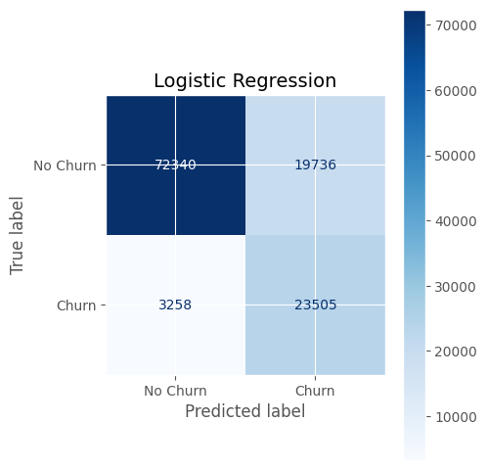
Figure 15 Logistic regression confusion matrix
The Logistic Regression model achieved the highest recall, correctly identifying most churn customers. However, its lower precision indicates more false positives, leading to unnecessary retention efforts.

HistGradientBoosting
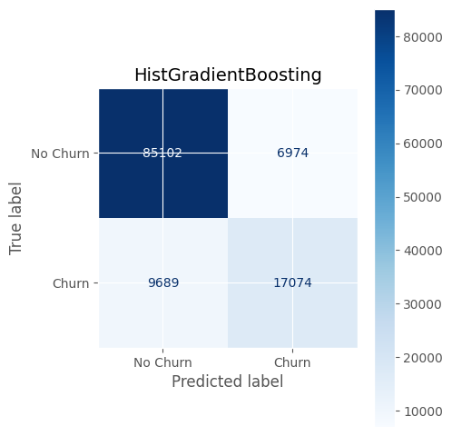
Figure 16HistGradientBoosting Confusion Matrix
large number of both non-churn and churn consumers. The model maintained competitive overall performance while significantly reducing false positive predictions when compared to Logistic Regression.

Random Forest
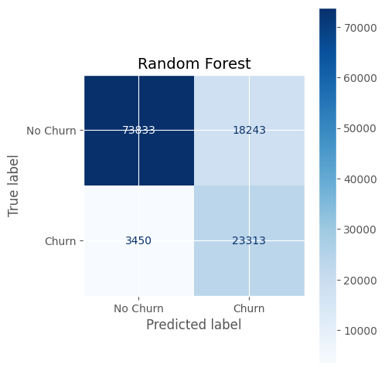
Figure 17 Random Forest confusion matrix

XGBoost

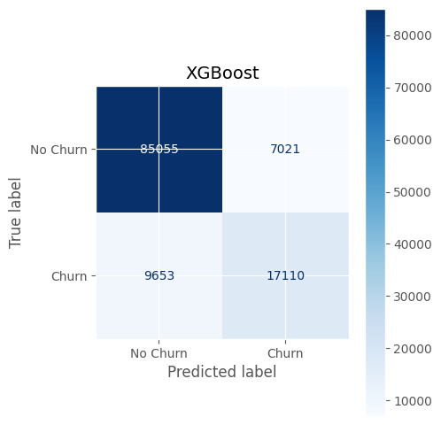
Figure 18 XGBoost Confusion Matrix

It was chosen as the final deployment model because of its excellent overall performance and best ROC-AUC.

Stacking Classifier
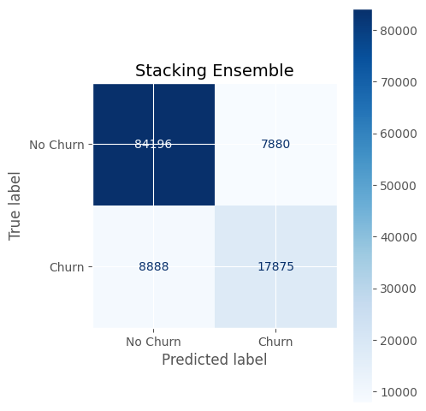
Despite its competitive predictive abilities, it required more computing complexity and only slightly outperformed XGBoost in terms of performance.

Selection of final model
Following comprehensive experimental evaluation, XGBoost was selected as the final prediction model for deployment within the developed customer churn prediction system.

- First, XGBoost achieved the highest ROC-AUC score (0.9153), demonstrating the best ability to distinguish between churn and non-churn customers.

- Second, it maintained a strong balance between recall and precision while achieving outstanding prediction accuracy.

- Third, XGBoost effectively simulates complicated feature interactions and nonlinear correlations that are frequently seen in consumer behavior data.

Although HistGradientBoosting and the Stacking Classifier achieved similar performance, the differences were marginal. XGBoost was therefore selected because it provided superior predictive capability together with efficient implementation and reliable generalization performance.

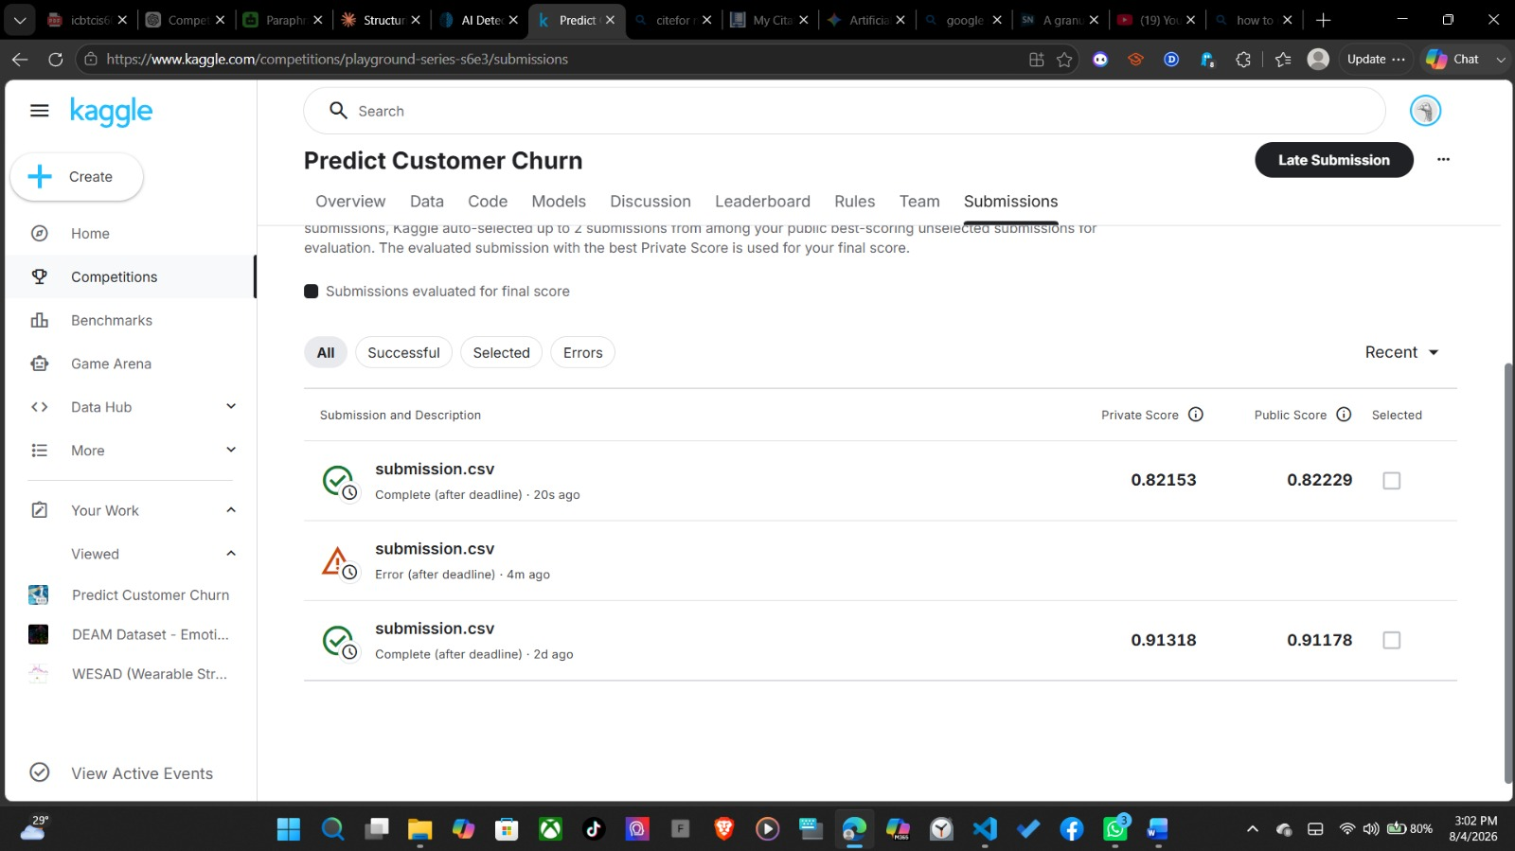
Kaggle Competition Submission and Leaderboard
Figure 19 Kaggle Competition Submission and Leaderboard

Implementation of the Streamlit Web Application
Streamlit was selected for its simple and efficient framework for developing machine learning web applications. The application allows users to enter customer information, which is processed using the same preprocessing pipeline before being passed to the trained XGBoost model for prediction.
- The prediction workflow includes:
- Customer data input
- Data preprocessing
- Churn prediction using the XGBoost model
- Risk assessment (High, Medium, or Low)
- Business recommendation based on risk level
- Display of prediction results through an interactive dashboard

The application is implemented using separate modules for the user interface, preprocessing, prediction model, and business logic, improving maintainability and future scalability.

Practical Demonstration
The developed Streamlit application demonstrates the practical use of the customer churn prediction model through the following steps.

Step 1: Launch the Application
The application is started using:
streamlit run app/app.py
The system opens in a web browser and displays the main interface.

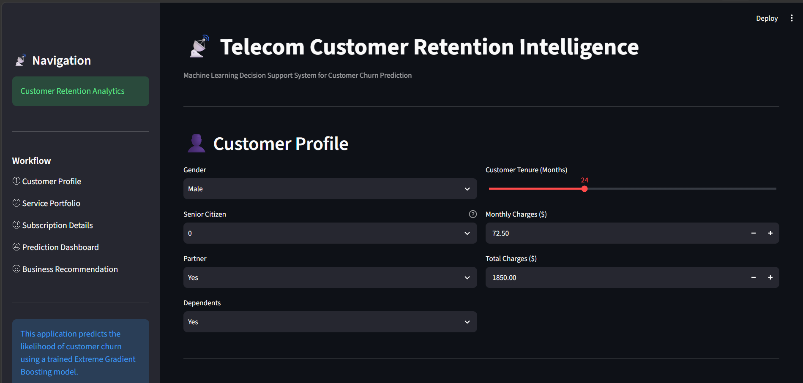
Figure 20 Home Page of the Customer Churn Prediction System

Step 2: Enter Customer Information

Users enter customer demographic, subscription, contract, payment, tenure, and billing information using the graphical interface. Figure

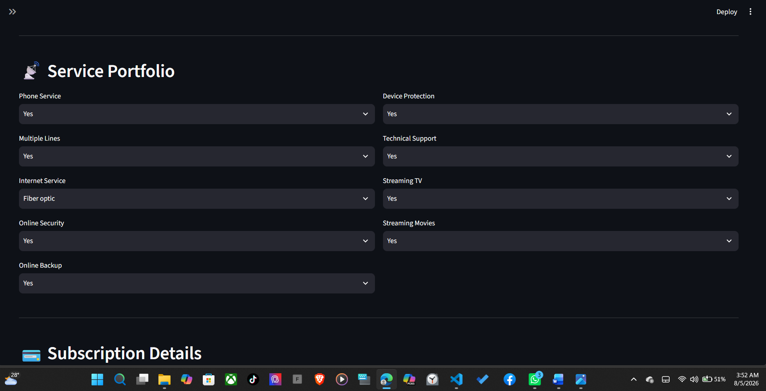
Figure 21 Enter Customer Information

Step 3: Generate Prediction

After clicking "Analyse Customer", the application preprocesses the input data and uses the trained XGBoost model to predict customer churn probability.

Step 4: View Prediction Results

The prediction dashboard displays:

- Predicted customer status
- Churn probability
- Risk category
- Customer profile summary
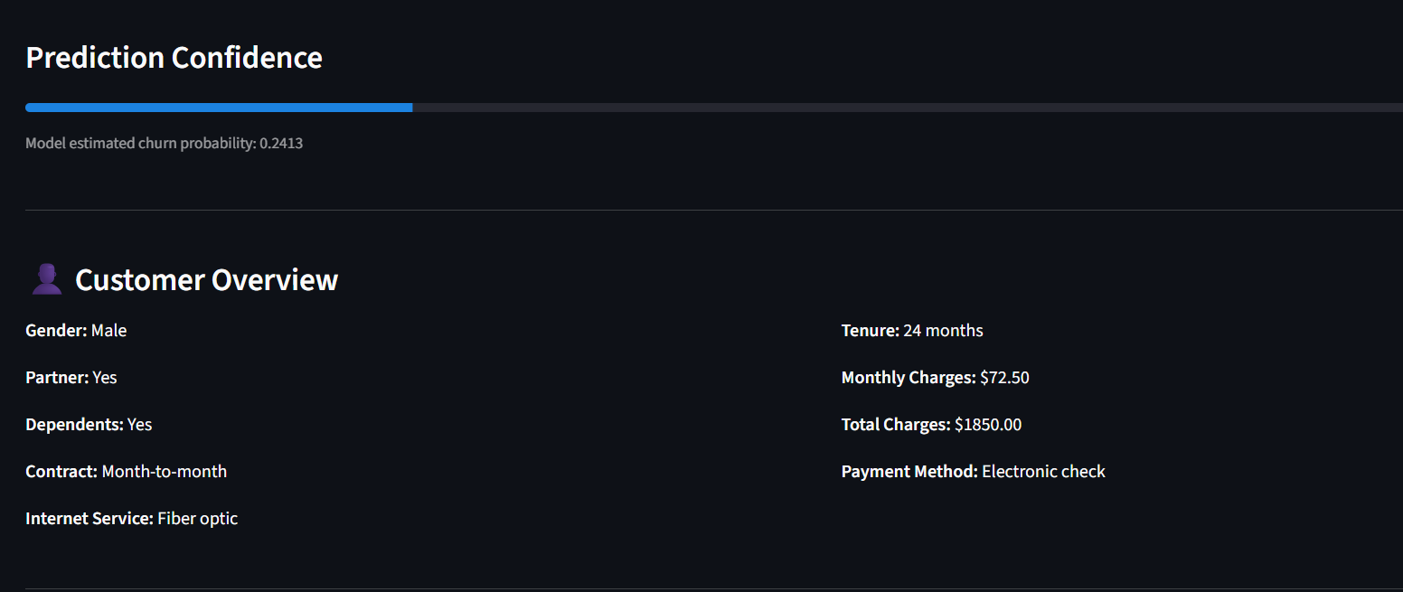
Figure 22 prediction dashboard displays:
Step 5: Business Recommendation

Based on the predicted risk level, the system provides suitable retention strategies

High Risk: Immediate retention actions (discounts, loyalty rewards, customer support).

Medium Risk: Targeted promotions and customer monitoring.

Low Risk: Continue regular engagement and monitoring.

Task F Critical Evaluation, Limitations and Future Work

Critical Evaluation of the Developed Model
XGBoost was the best-performing model out of the five models that were assessed, with the greatest ROC-AUC score (0.9153).

Every model has advantages of its own. The highest recall was attained by logistic regression, while the highest F1-score was acquired by random forest. Additionally effective were the Stacking Classifier and HistGradientBoosting. But when it came to accuracy, precision, recall, and ROC-AUC, XGBoost had the finest overall balance.

A Streamlit web application successfully implemented the XGBoost concept. The tool is helpful for customer retention choices as it not only forecasts client attrition but also offers risk assessments and business suggestions.

Suitability of Computational Intelligence for Customer Churn Prediction
Customer churn depends on many factors such as customer details, service usage, contracts, and billing information. These relationships are complex and difficult to identify using traditional rule-based methods.

Computational intelligence techniques can learn patterns from historical data and make accurate predictions without manually creating rules. The results of this project show that ensemble models, especially XGBoost and HistGradientBoosting, are well suited for customer churn prediction because they achieved high predictive performance.

Comparison with Previous Research
The results of this project are similar to previous studies reviewed in . Like earlier research, XGBoost produced one of the best prediction results among the evaluated models.

The application makes the solution more useful for real-world usage by enabling users to monitor risk levels, estimate client attrition, and obtain business suggestions.

Limitations of the Developed System
- First, the model's performance may differ when utilizing data from different organizations because it was trained on a single Kaggle dataset.

- Second, since the application isn't linked to a live database, users must manually enter clientdata.

- Third, compared to simpler models, consumers have a harder time understanding why a forecast was made using XGBoost.

- Finally, because client behavior varies over time, the model needs to be retrained often to maintain accuracy.

Future Improvements
Several improvements can be made in the future.

- The program may be linked to real-time corporate databases to automate customer data entry.

- Explainable AI approaches, such as SHAP or LIME, can be used to assist people comprehend prediction findings.

- Future research can compare the performance of deep learning models like Artificial Neural Networks (ANNs) to that of XGBoost.

- The model can also be automatically retrained with fresh client data, and the Streamlit app may be upgraded to a cloud-based solution complete with user login, dashboards, and CRM connectivity.

Summary
This task assessed the created customer churn prediction system and found that computational intelligence is successful at forecasting customer turnover.XGBoost was selected as the final model since it showed the highest overall performance. To improve usability and scalability, the chapter also discussed the system's weaknesses and suggested future improvements including Explainable AI, database integration, automatic model retraining, and cloud deployment.

Conclusion
Using the Kaggle Playground Series – Season 6, Episode 3 dataset, this project effectively created a machine learning-based customer churn prediction system. Five machine learning algorithms—Logistic Regression, HistGradientBoosting, Random Forest, XGBoost, and the Stacking Classifier—were put into practice and assessed. With a ROC-AUC score of 0.9153 and the greatest overall performance based on the testing findings, XGBoost was chosen for deployment.

The project also demonstrated the practical application of computational intelligence by developing a Streamlit-based web application that enables users to predict customer churn, assess customer risk levels, and receive business-oriented retention recommendations. This transforms the predictive model into a useful decision-support system for telecommunication companies.

By evaluating several machine learning models, choosing the best algorithm, and implementing it in an intuitive web application, the project successfully met its goals. The results verify that computational intelligence methods are useful for predicting customer attrition and can help businesses make data-driven decisions and increase customer retention. Future improvements like automatic model retraining, explainable AI, and real-time database integration might boost the system's functionality and usefulness.

References

literature review references
- Lalwani, P., Mishra, M.K., Chadha, J.S. and Sethi, P., 2022. Customer churn prediction system: A machine learning approach. Computing, 104(2), pp.271–294. Available at: https://doi.org/10.1007/s00607-021-00908-y.
- Anjana, K.V. and Urolagin, S., 2021. Churn Prediction in Telecom Industry Using Machine Learning Algorithms with K-Best and Principal Component Analysis. In: Applications of Artificial Intelligence in Engineering. Singapore: Springer, pp.499–507. https://link.springer.com/chapter/10.1007/978-981-33-4604-8_40
- Lan, B., Chen, Y. and Wu, K., 2025. A granular XGBoost classification algorithm. Applied Intelligence, 55(13), p.895. https://doi.org/10.1007/s10489-025-06762-1
- Manzoor, A., Qureshi, M.A., Kidney, E. and Longo, L., 2024. A review on machine learning methods for customer churn prediction and recommendations for business practitioners. IEEE Access, 12, pp.70434–70463. Available at: https://doi.org/10.1109/ACCESS.2024.3402092. (Arrow)
- GeeksforGeeks, 2025. Evaluation Metrics in Machine Learning. Available at: GeeksforGeeks – Evaluation Metrics in Machine Learning
- Wolpert, D.H., 1992. Stacked generalization. Neural Networks, 5(2), pp.241–259. Available at: https://doi.org/10.1016/S0893-6080(05)80023-1
- Brownlee, J., n.d. A Gentle Introduction to the Confusion Matrix in Machine Learning. Machine Learning Mastery. Available at: https://machinelearningmastery.com/confusion-matrix-machine-learning/

Data set link
- Kaggle, 2026. Playground Series – Season 6, Episode 3: Predict Customer Churn. Available at: https://www.kaggle.com/competitions/playground-series-s6e3

